I 1)Install git.

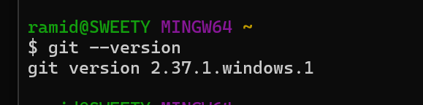

2)Create a repo in github with README.md and .ignore file.

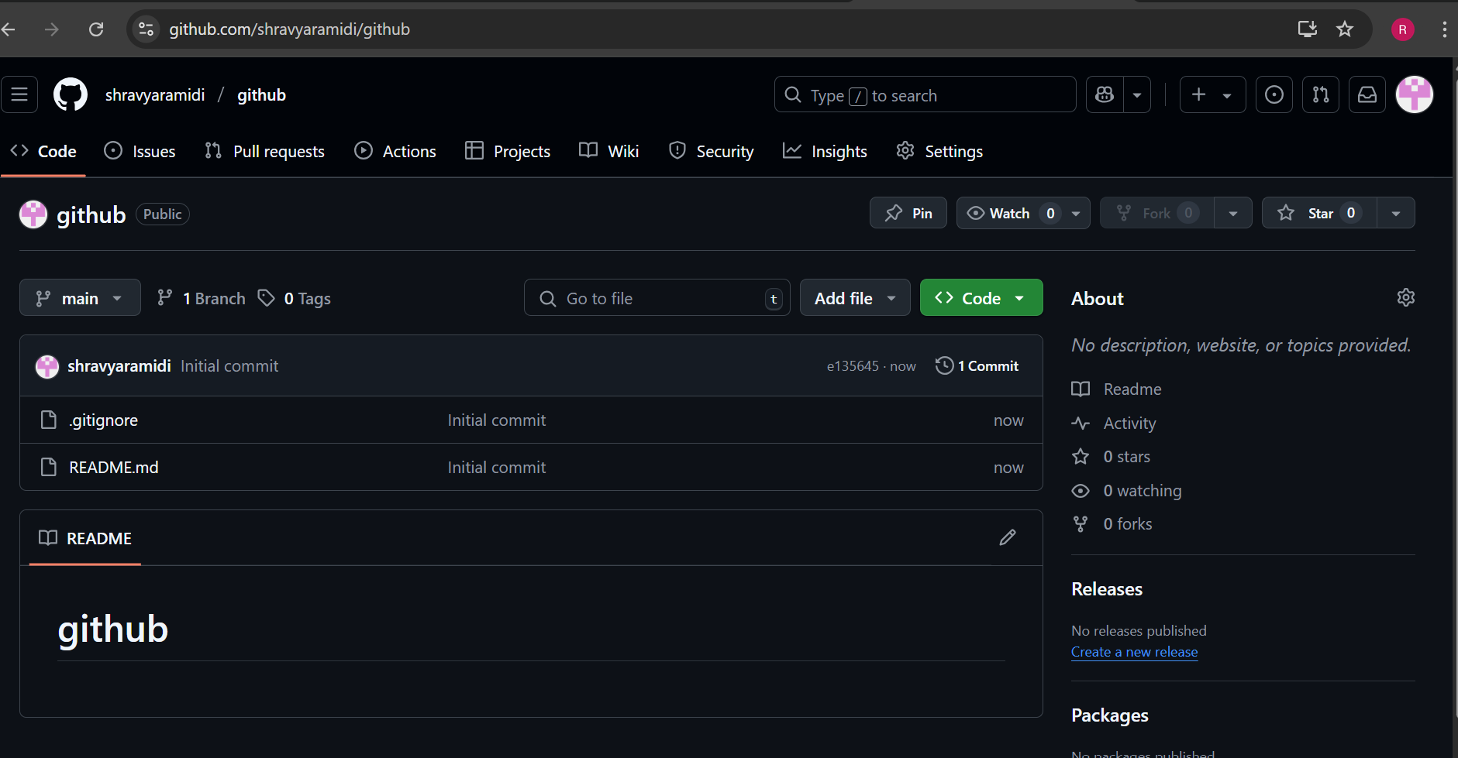

3)Clone the created repo to local.

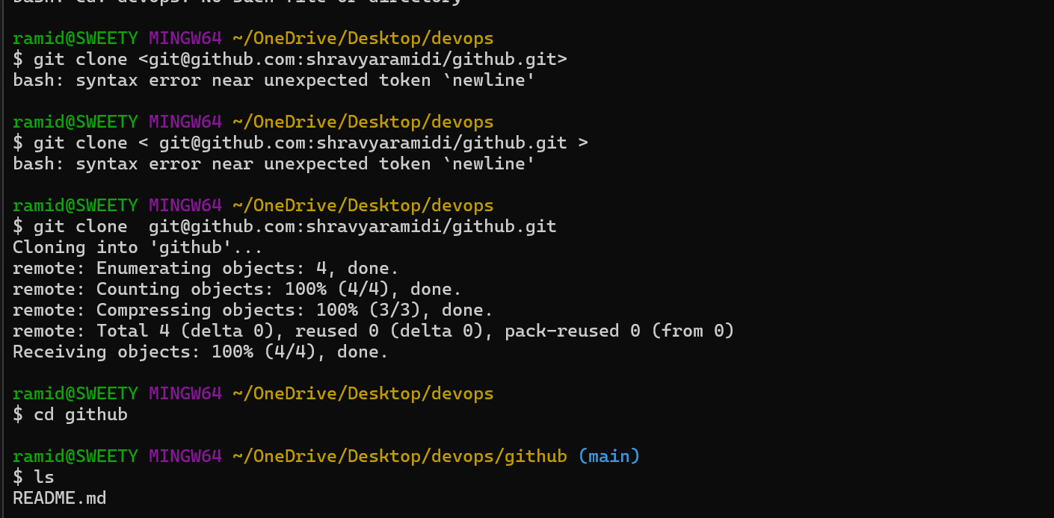

4)Create two files in local repo.

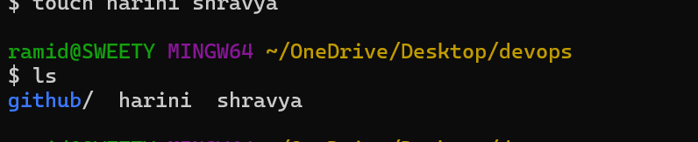

5)Commit two files and push to central Repository.

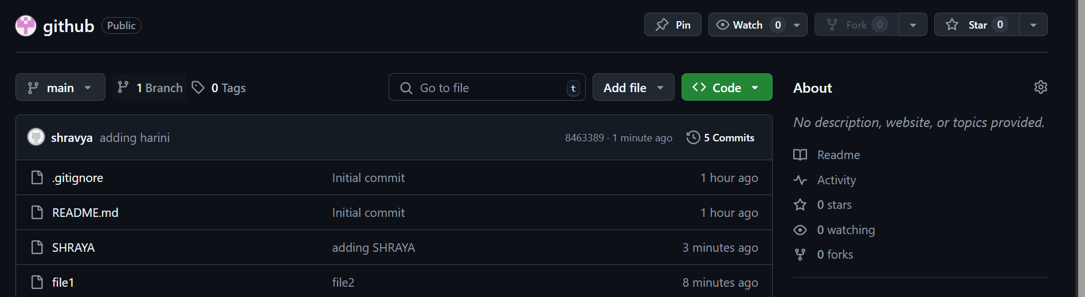

6)Create a branch in local and create a sample file and push to central.

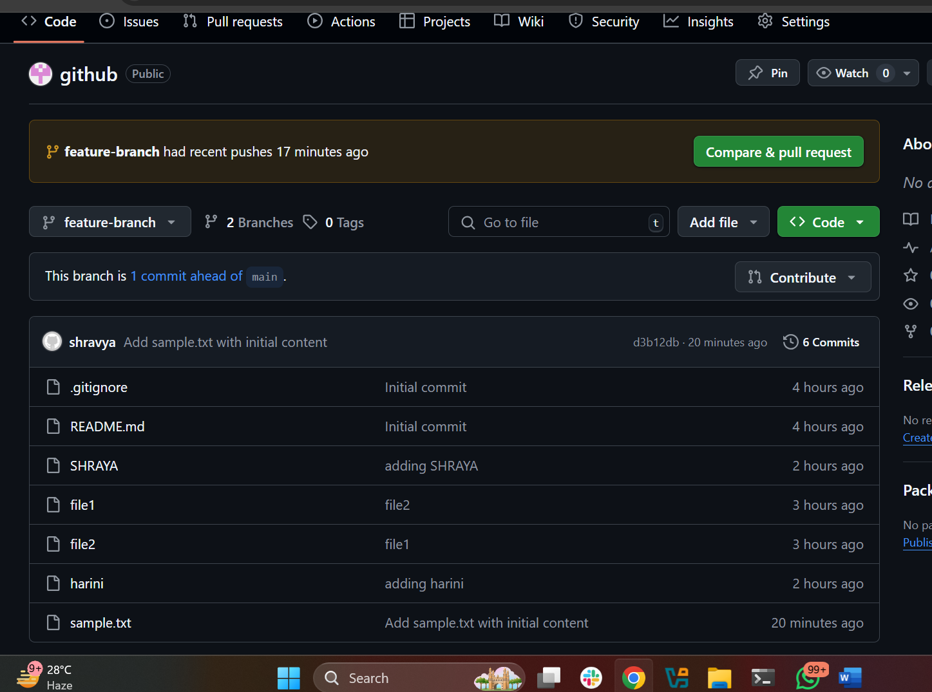

7)Create a branch in github and clone that to local.

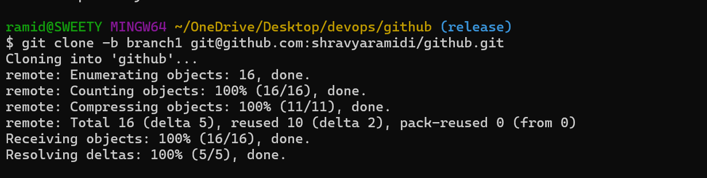

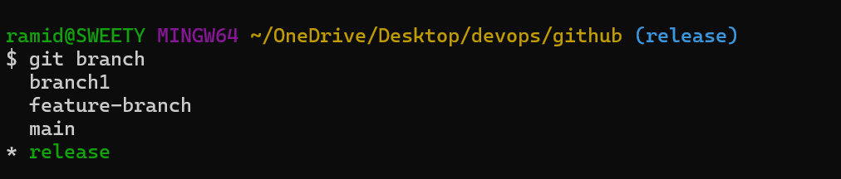

8)Merge the created branch with master in git local.

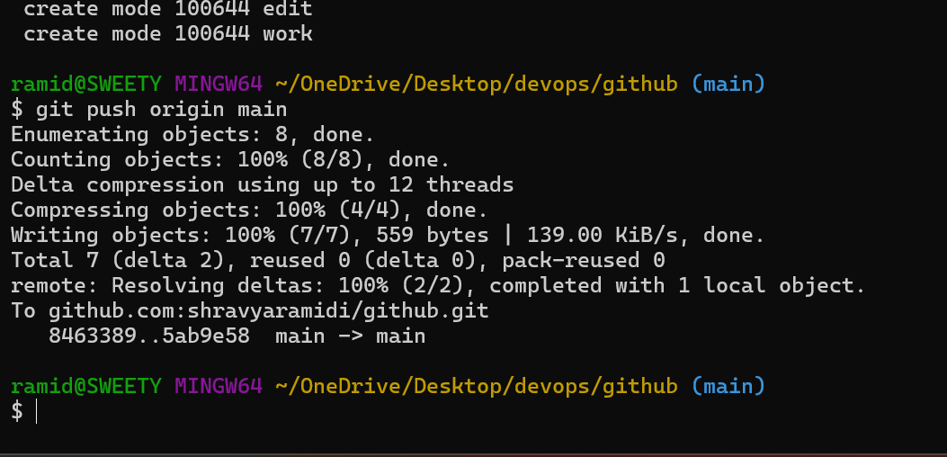

9)Merge the created branch with master in github by sending a pull request.

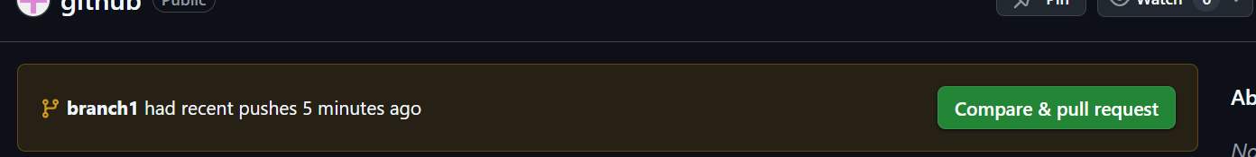

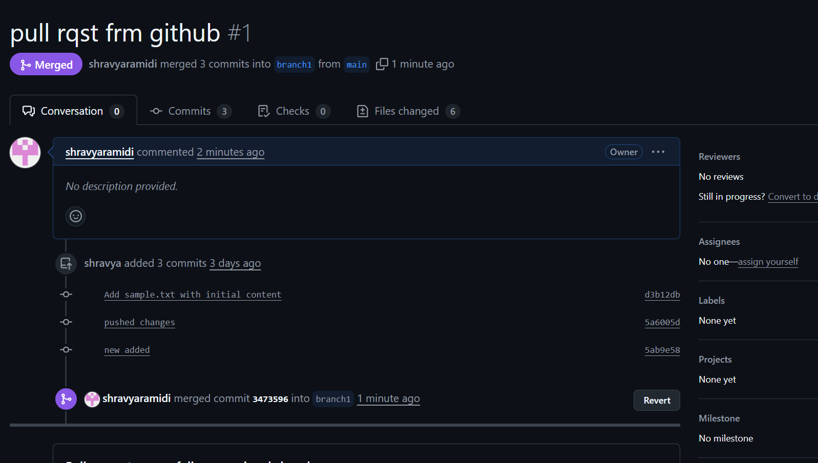

10)create a file in local and send that to branch in github.



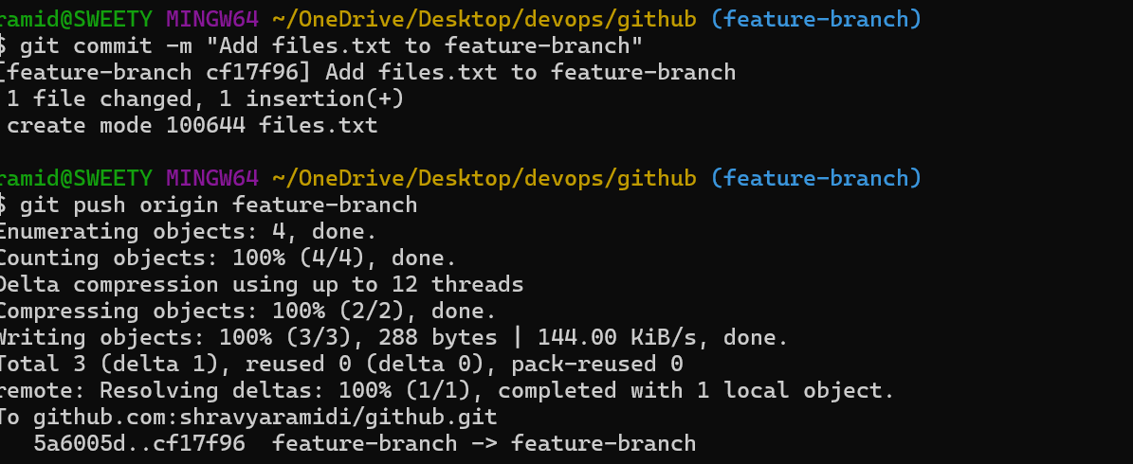

11)clone only one branch from github to local

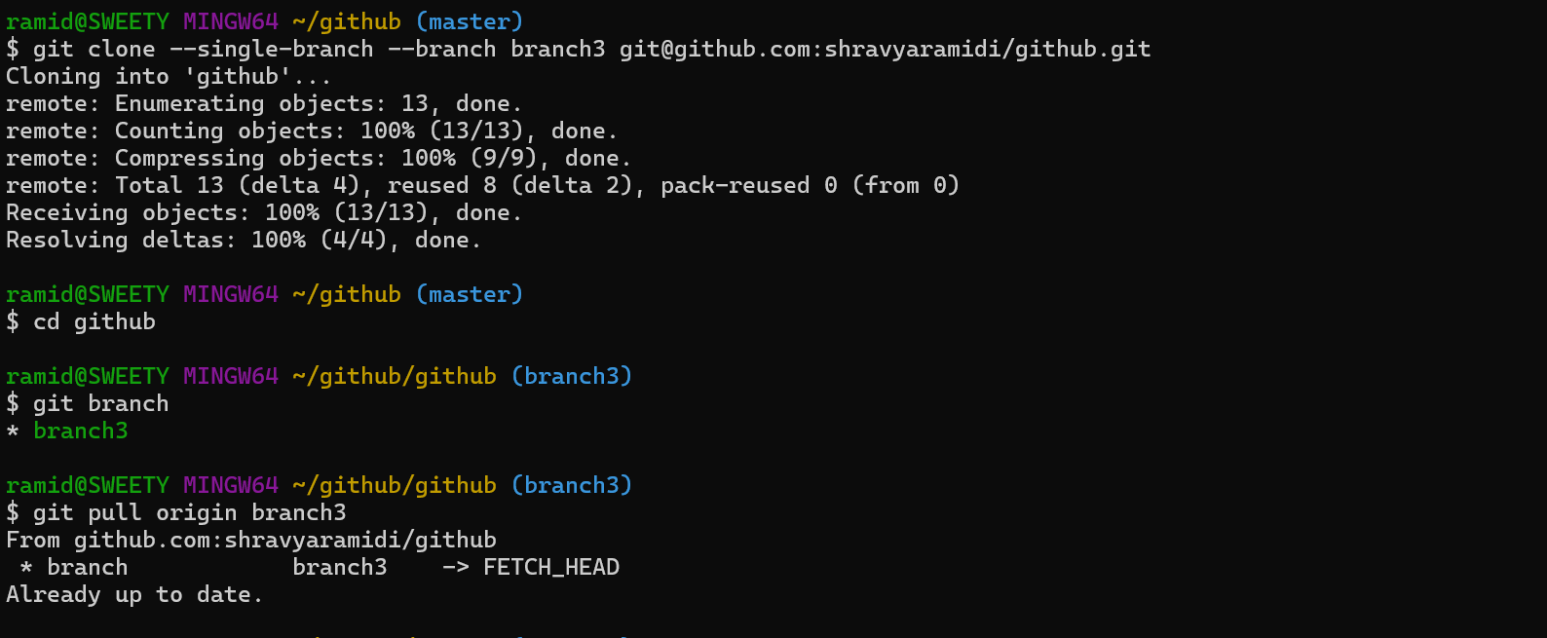

12)make a commit and make that commit reset without savings changes.

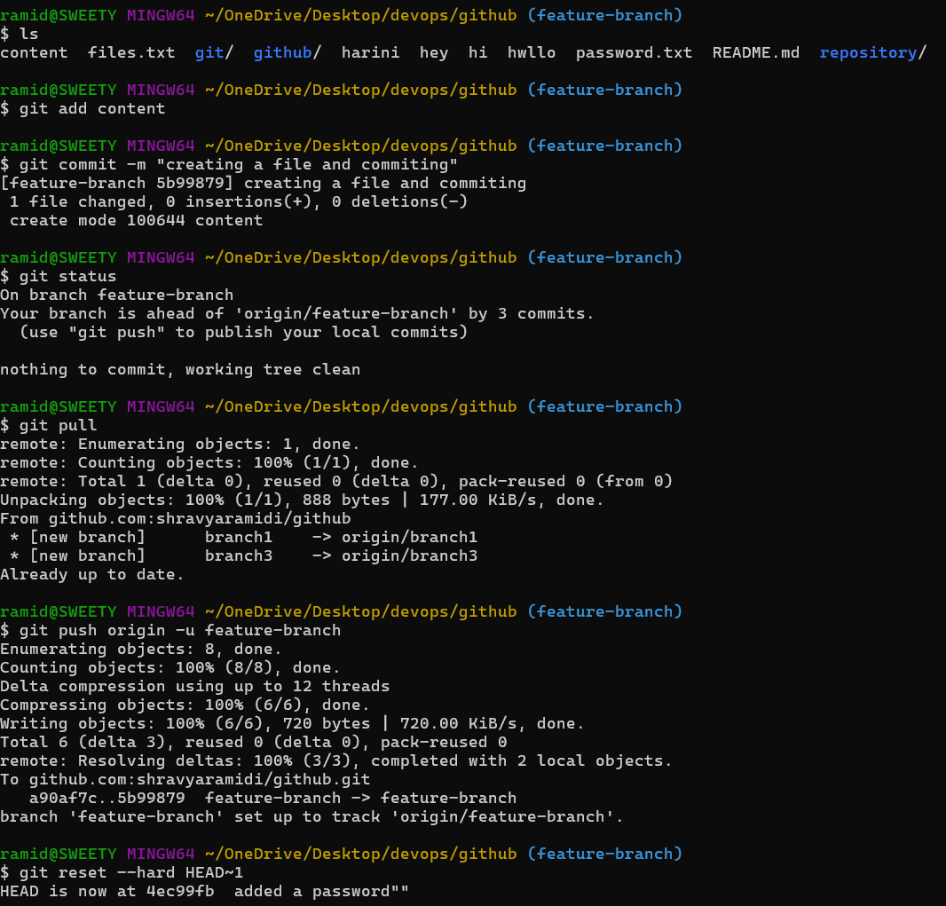

14)Revert a commited commit to the older version.

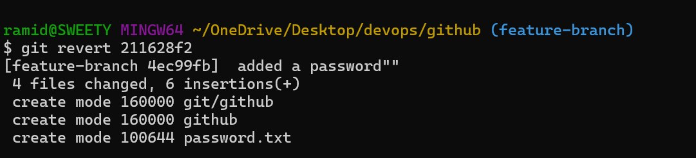15)push a file to stash without savings the changes and work on another file.

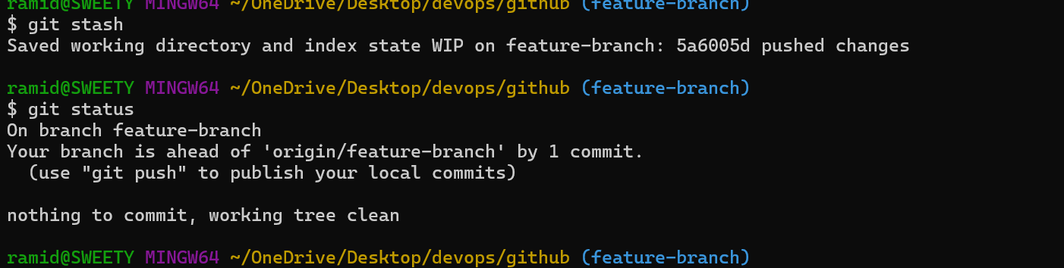

16)undo the stash file and start working on that again.

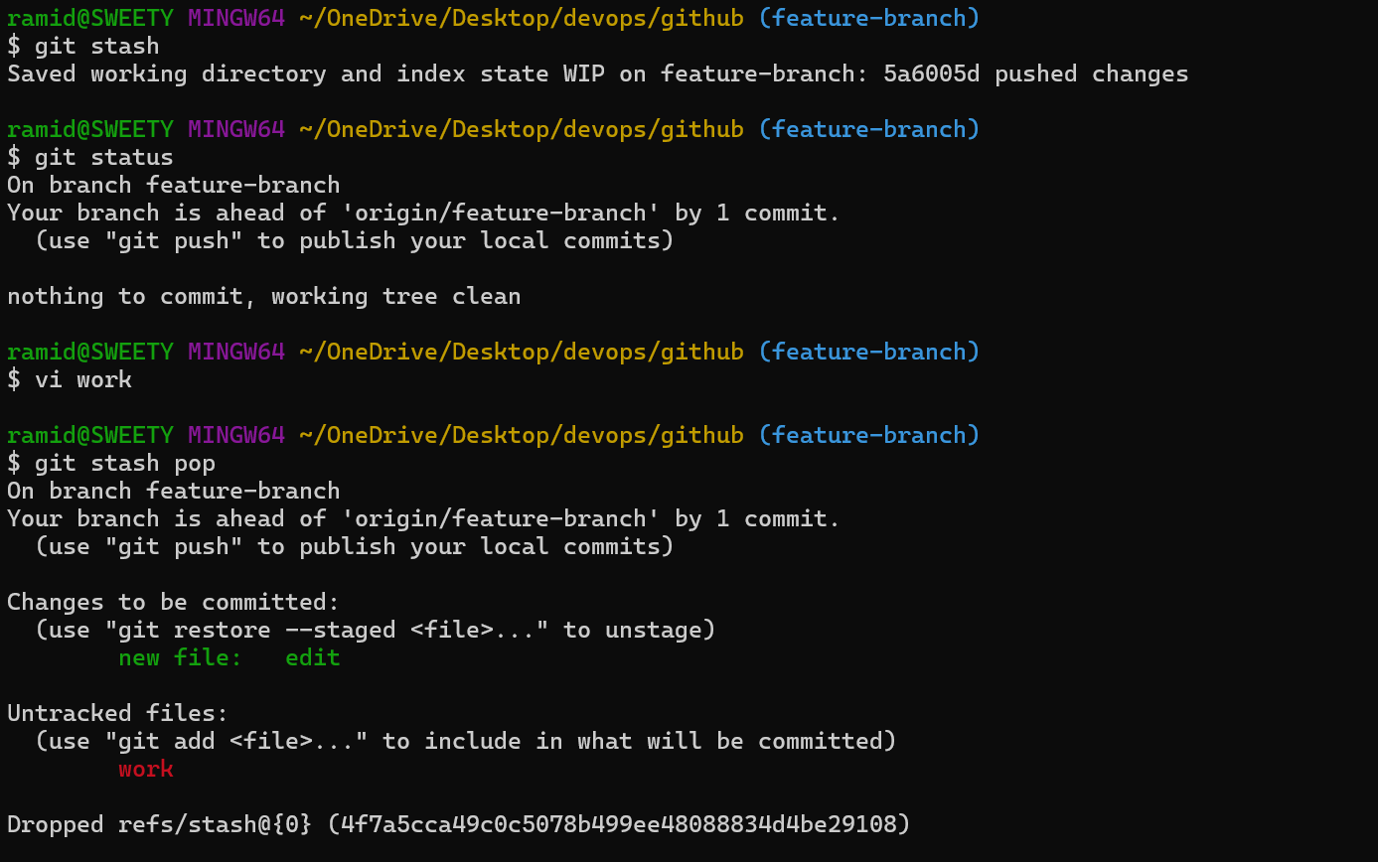17)generate a ssh-keygen and configure into github.

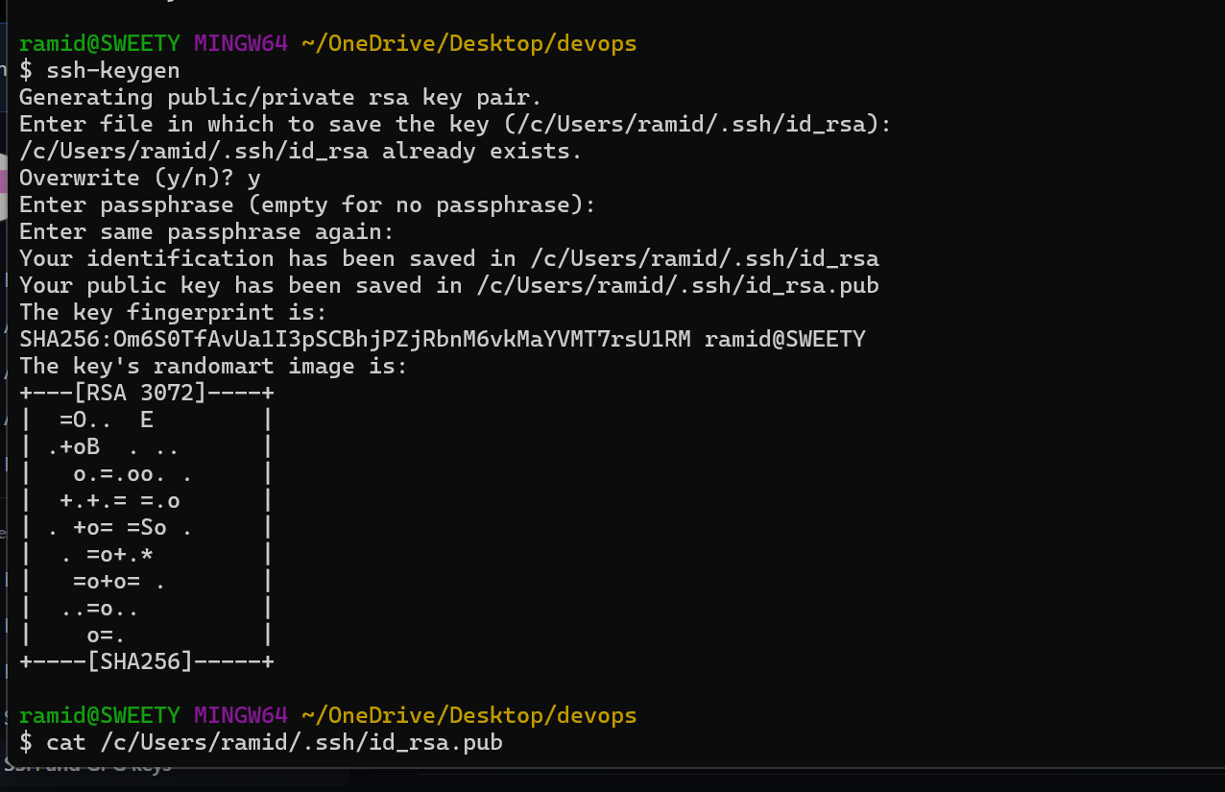

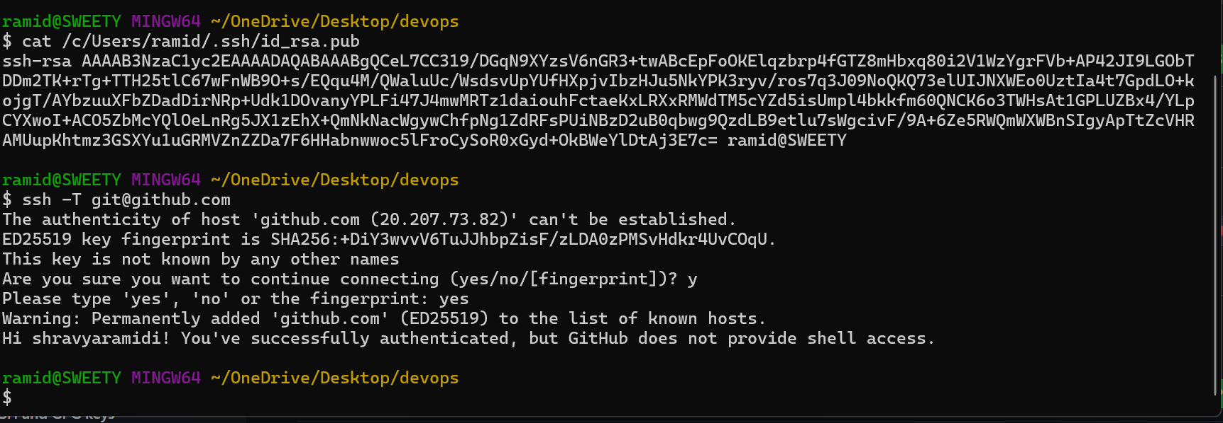

18)configure webhooks to github.

19)basic understanding of .git file.

The .git directory is a hidden folder in your project that Git uses to store all the information and metadata necessary for version control. It's essentially the repository's brain, where all the magic happens. When you initialize a Git repository with git init, this directory is created

20)Check all the logs of git.

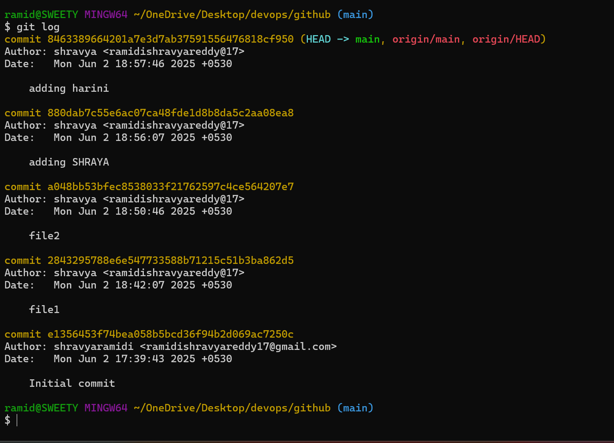

21)Rename the commit message.

